**AI ASSISTED CODING LAB TEST-2**

NAME:K SRIKAR

ENROLL NO:2503A51L03

BATCH:24BTCAICSB19

SUB GROUP: G

**TASK 1:** Sum CSV column ignoring bad rows

**PROMPT:**Sum 'value' ints; skip invalid rows.

Sample Input  
id,value  
1,10  
2,NA  
3,7

**CODE GENERATED:**

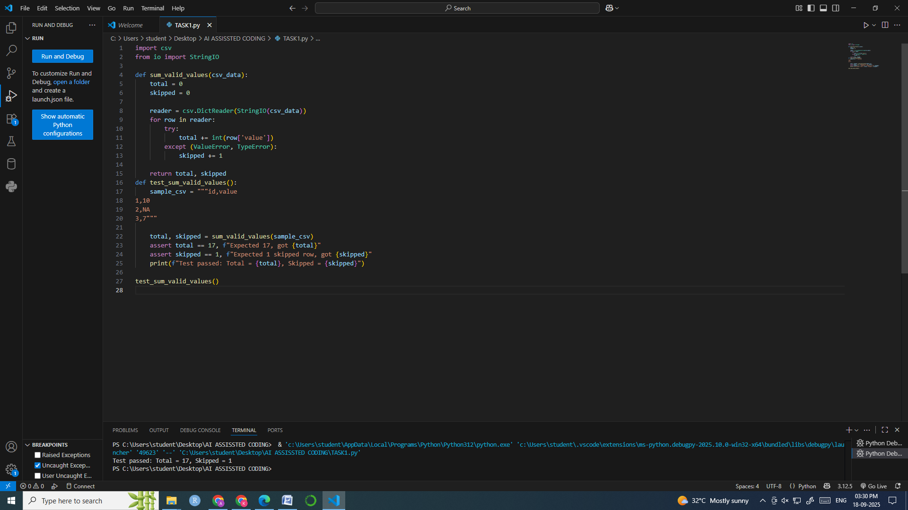

**OUTPUT:**



**OBSERVATION:**

* The program reads each row using csv.DictReader.
* It attempts to convert the 'value' field to an integer.
* Row 2 contains 'NA', which is invalid and skipped.
* Valid rows (1 and 3) are summed correctly: 10 + 7 = 17.
* The program also reports that 1 row was skipped due to invalid data.

**TASK2:** Merge two CSVs by id

**PROMPT:**

Implement inner & left joins without pandas.  
Sample Input  
id,price  
A,10  
B,20  
---  
id,qty  
A,2  
C,5

**CODE GENERATED AND OUTPUT:**

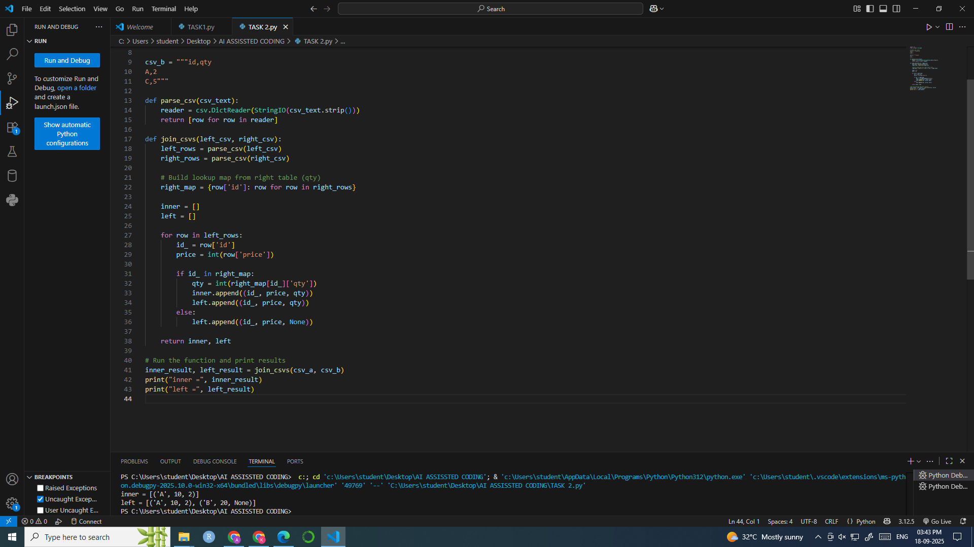

**OUTPUT:**



**OBSERVATION:**

* The program parses both CSVs and builds a dictionary from the second file (qty).
* It performs an **inner join** by matching IDs present in both files: only 'A' matches.
* It performs a **left join** by retaining all rows from the first file and adding matching data from the second file.
* 'B' has no match in the second file, so its qty is set to None.
* The output preserves the order of the first file and correctly reflects join semantics.